Help Support Vision Christian Academy
by ordering your copy of
Rise and Walk CD
featuring the House of Prayer Singers
&
House of Prayer Cookbook
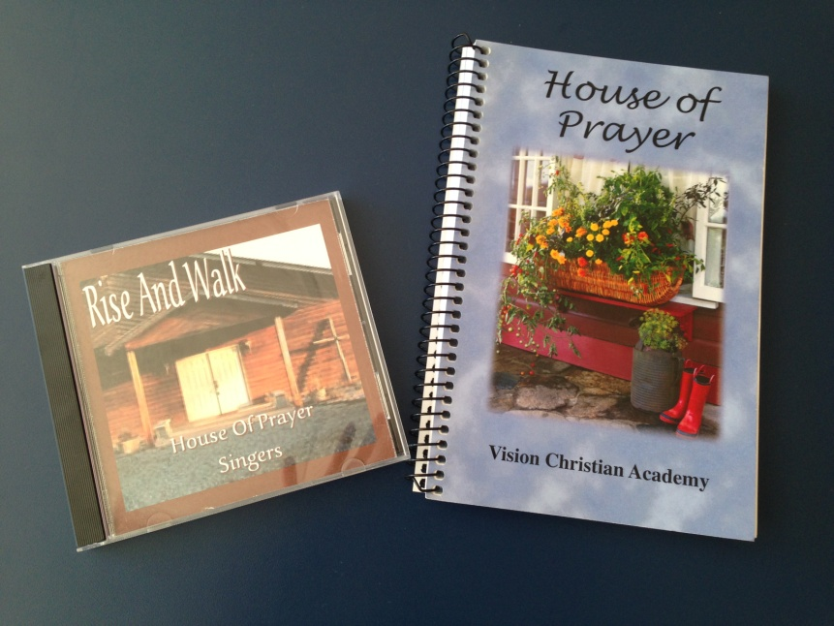

Item Description | Quantity Ordered |  | Price Each |  | Total Amount Due
Cookbook | ____ | X | $10.00 | = | _____
Rise and Walk CD | ____ | X | $12.00 | = | _____
Shipping & Handling | ____ | X | $3.95 | = | _____
Total Amount Due |  |  |  |  | _____

Mail Check or Money Order along with this order to:

Vision Christian Academy
ATTN: Cookbooks & CD orders
P. O. Box 217
Winona, MO 65588
or Call 573-325-4008

Please allow 2-4 weeks for delivery

